A Lonely Abyss:

Rulebook



|  |  |  |  |
| --- | --- | --- | --- |
| Name | Student Num | Email Address | Pathway  (CS, SE, SESE, Joint) |
| James Bailey | 40156063 | jbailey05@qub.ac.uk | CS |
| JP (Joseph) Devlin | 40150554 | jdevlin40@qub.ac.uk | CS |
| Jordan McComb | 40156883 | jmccomb12@qub.ac.uk | CS |
| Patrick Conway | 40150555 | pconway10@qub.ac.uk | CS |
| Kyle Bell | 40158884 | kbell24@qub.ac.uk | CS |

**What is A Lonely Abyss?**

**A Lonely Abyss is a card trading game set in an alternative Queen’s University in which the world has fallen to ruin. Within this world lies powerful magical creatures known only as Unimon, beings and deities that wield powers that mankind simply cannot fathom. The player must use these Unimon as cards to battle an opposing player (AI or human controlled) in three forsaken locations filled with dangerous adventure. One player can explore a location by traversing a random map grid and upon landing on a single grid tile either battle the opposing player, receive a reward or incur a penalty. Each player’s end goal of the game is to build an imposing deck, through trading or receiving prize cards, that is capable of winning many battles.**

**Getting Started – Deck Formation**

1. **The two players are each required to assemble a deck of at least 35 cards to bring into battle. They must use this card limit wisely as they will need to build a well-balanced mixture of Unimon, resources, and support cards.**
2. **Five, basic *unevolved Unimon cards* are chosen by the respective players to be placed on a special play area called *‘the Bench’*. Only cards on bench can be used to attack the opposing Unimon cards. Players then shuffle the deck.**
3. **Each player draws three cards from the deck face down to an area called *‘the prize area’.***
4. 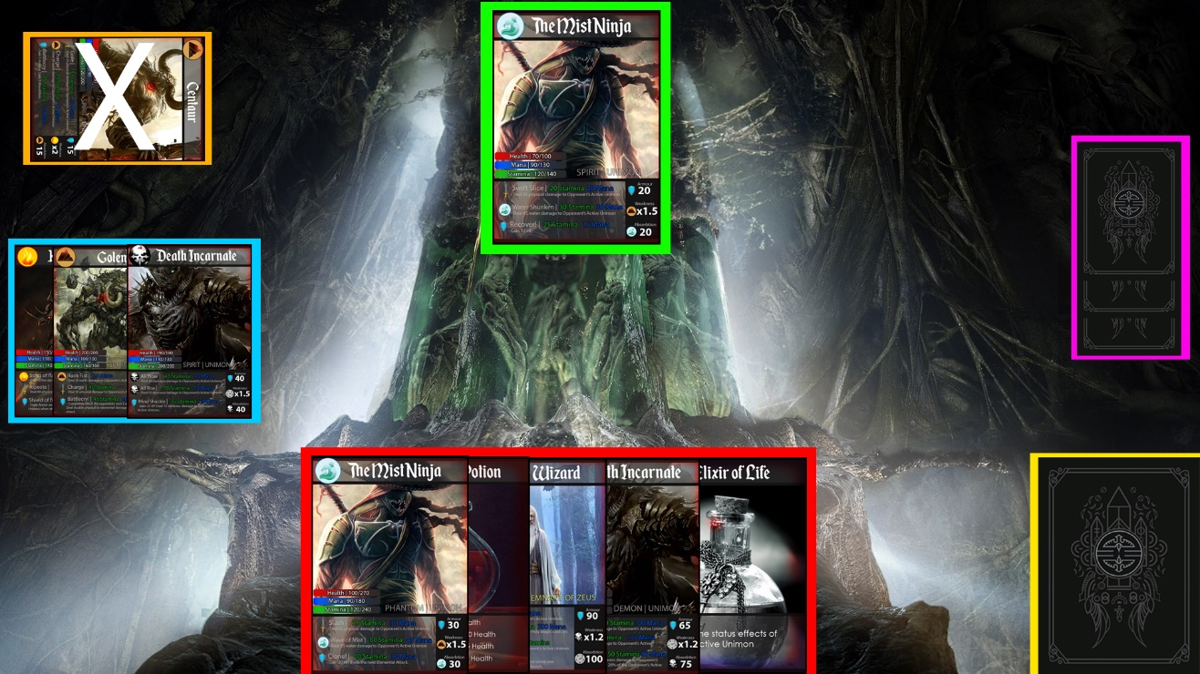**Five cards are drawn from the deck face up to an area called *‘the resource area’.***

**Active Card**

**Hand**

**Prize cards**

**Deck**

**Graveyard**

**Bench cards**

**Example deck formation**

**Getting Started – Map Navigation**

1. **The map will be split into tiles that the player cannot see.**
2. **Once the player steps onto a tile it is revealed to him.**
3. **The tile governs what happens to the player next.**
4. **The furthest tile in an area will the exit to that area and the entrance to the next**
5. **Each time a player revisits an old area the tiles will be reshuffled so that they contain new loot and dangers.**
6. **The contents of each tile is determined by a random number generator and the players level**

**Example grid formation**

|  |  |  |  |
| --- | --- | --- | --- |
| **Start** |  |  |  |
|  |  |  |  |
|  |  |  |  |
|  |  |  | **Exit** |

**Tile events**

* ***Unimon grid card*: the user gets to add this card to their deck.**
* ***Battle grid card*: Player 1 and Player 2 must go to the playing field were their decks will be waiting.**
* ***Generic location based card:* Player 1 takes no action.**
* ***Grid movement card:* Player 1 moves their counter to the grid square the arrow is pointing at.**
* ***Trading window grid card: Players can trade cards.***

|  |  |  |  |
| --- | --- | --- | --- |
| **Start** |  |  |  |
|  |  |  |  |
|  |  |  |  |
|  |  |  | **Exit** |

**Example Grid Movement**

**How to Play – Battle Field**

1. **Both players must set up their deck formation for the new battle scene (see Getting Started – Deck Formation)**
2. **Each player will have to roll a dice or flip a coin in order to determine which player makes the first move in battle.**
3. **The first player to battle must select one of their *unevolved Unimon cards* from the bench and place it in the *attack/battle area.***

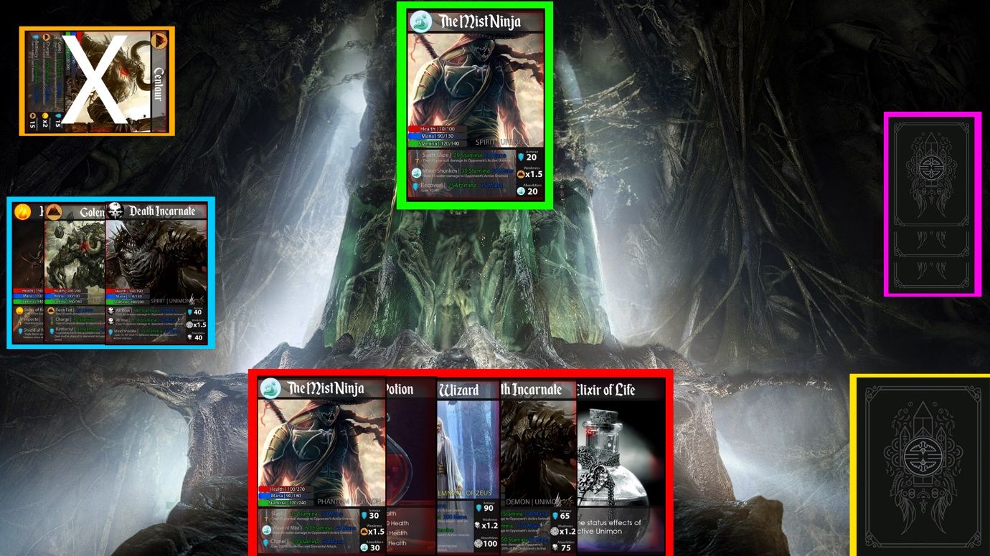

Attack/Battle Area

**Step 3**

**Field**

1. **The second player can then perform step 3.**
2. **Each *turn* a player can perform a number of key actions in order to battlethe opponent’s *in active Unimon*.**
3. **If the player lowers the opponent’s active Unimon card’s health to zero, then they have achieved a knockout victory. The opponent’s knocked out Unimon is moved to their graveyard area.**
4. **After each knockout, the winning player takes one of their opponent’s prize cards from the prize area.**
5. **They player gains experience points for each battle (more for winning) which is used to level up which gives access to more powerful cards and tougher areas of the world.**

**Types of actions**

* ***Evolve active Unimon*: If a player has a *Unimon card* in their *resource area* that is of *at most one* *higher evolutionary* stage (Unique > Demon > Phantom > Spirit) then you can place the card upon the *current active Unimon*, replacing it.**

**Example Evolving Active Unimon Card**

* ***Retreat*: A player can choose to withdraw their active unimon to the bench. This retreat is performed immediately and a new Unimon must be selected from the bench. This uses up 1 turn.**
* ***Choose active Unimon:* The player can choose a benched Unimon to be moved to the active**
* ***Perform active Unimon’s move:* If the player has the required *mana and/or stamina* to perform their *active Unimon’s move* they can inflict *listed effects* on themselves or their opponents *active Unimon*.**
* ***Increase Unimon’ energy:* Using *potion cards* in the *resource area* the player can replenish the *mana, stamina and health* of either their *benched* or *active Unimon as well as cure deadly status effects.* The resource card is then discarded to the player’s *graveyard area* and a card is retrieved from the top of the *deck* and placedinto the *resource area*.**
* ***Discard resource cards:* The player can discard a *resource card* to their *graveyard area* and retrieve a replacement *resource card* from the top of their *deck*. This uses 1 turn.**

**Win conditions**

* **The opponent has had three of their Unimon knocked out, hence all three of their prize cards have been won by the opposing player.**
* **The opponent is unable to draw a card from their deck as there are no remaining cards.**

**Example Unimon Card**

Name

Elemental Type

Evolutionary Stage

Key Attributes

Type of card

Moves

Armour rating

Elemental power multipliers

Character image



**Elements**

|  |  |
| --- | --- |
| **Elements** | **Description** |
| Fire | Its destructive and fierce might to attack is matched by no other but Unimon’s with this type are susceptible to heavy damage, especially when being submerged in water. This intense energy is especially effective against Earth type Unimon. |
| Water | Not as effective as fire type Unimon in flowing attacks but it is generally well balanced, being competent in defending, especially against fire type Unimon. However, it is susceptible to mainly physical attacks from Earth type Unimon. |
| Earth | Extremely effective in neutralising general attacks but its moves are not as penetrating. They are effective against water type Unimon but struggle against fire. |
| Dark | An extremely rare elemental type that have the potential to inflict massive damage. It can inflict massive damage upon all elemental types. It is also extremely effective against Holy Magic. |
| Holy | An extremely rare elemental type that can defend itself effectively from the majority of attacks. It is also extremely effective against Dark Magic. |

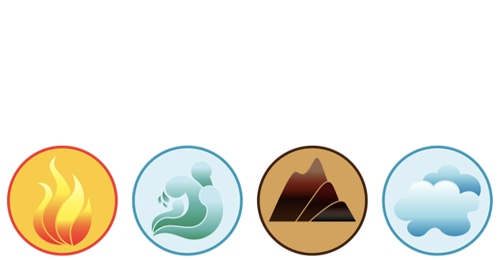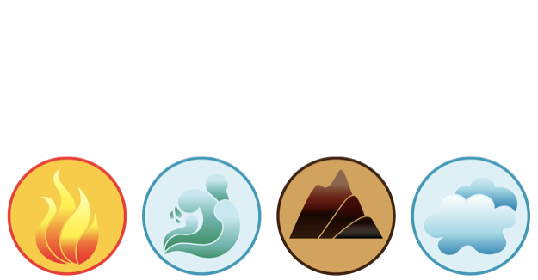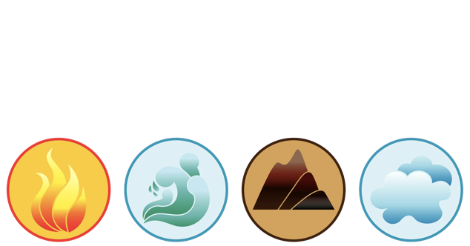

**Attributes**

Health – affects the battle readiness of the *Unimon*. If the health is reduced to 0 the Unimon is *knocked out* and cannot be used again in the current battle. Health is reduced through opponent moves. Health can be replenished through absorbing opponent move effects or using the card’s elemental attacks on itself. Health can also be replenished through health poison.

Mana – affects the potential for the Unimon to perform mainly *elemental attacks*. Mana can be replenished through *potions*

Stamina - affects the potential for the Unimon to perform mainly *physical attacks*. Stamina can be replenished through potions.

Armour – used to negate a certain percentile amount of opponent’s physical effects.

**Elemental power multipliers**

Weakness – certain elemental types are susceptible to increased elemental attack damage from opposing elemental type Unimon. The multiplier increases the opponent’s elemental attack damage by the stated numerical value.

Absorption – takes the form of the Unimon’s own element; any damage taken by this element will increase the Unimon’s health by this percentage of the damage (i.e. if you are attacked by 300 dark damage and you absorb 90% dark you will take no damage but instead gain 270 health)

**Top of Form**

**Moves**

Physical Attacks – always requires stamina, in some occasions require a small quantity of mana. The effects of physical move on the opponent are reduced by the opposition’s Unimon’s armour percentile value.

Elemental Attacks – always require mana, in some occasions require a small quantity of stamina. The effects of elemental moves on the opponent are increased by the opponent’s weakness multiplier.

Defensive Move – for most Unimon requires a spread of both mana and stamina. Can be used to manipulate armour or absorption attribute to better equip your Unimon for incoming attack.

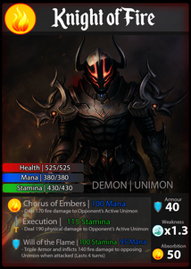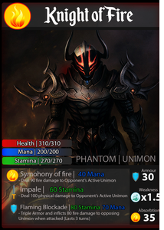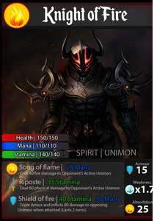**Evolutionary Stages**

**Unique Unimon can then be placed on top of any Demon card, regardless of its type. These are exceedingly rare cards that are usually only seen or experienced in the end game. They have the strongest move-set, largest Health, Mana and Stamina pools in the entire game. These are identified by their text on the card.**

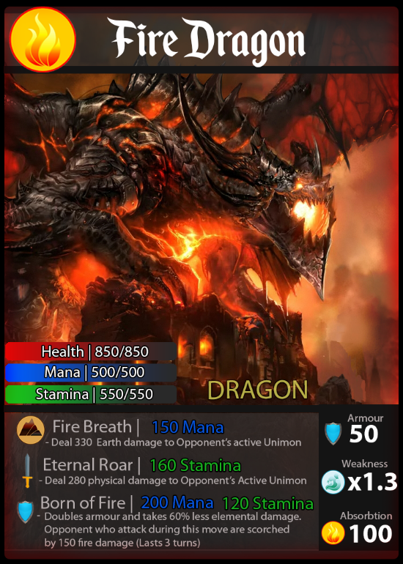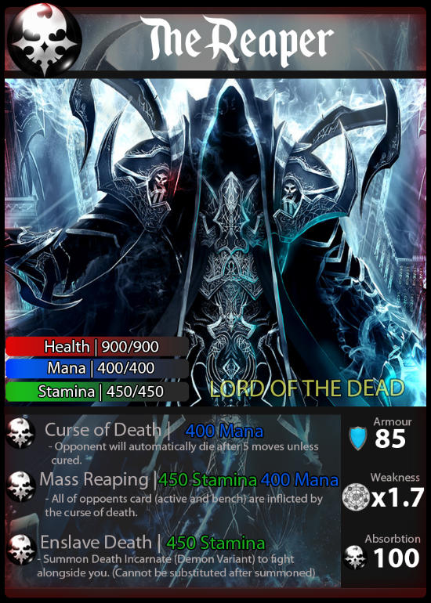

**Potions**



Image

Potion logo

Name of Potion

Evolutionary stage: effect

